Library Name: | cgm
Cell Name: | NAND2XI
Function/Truth Table:
A B |  | Y
0 0 |  | 1
0 1 |  | 1
1 0 |  | 1
1 1 |  | 0
Propagation Delay (path based):
Transition |  | Delay (s)
A → Y ↑ (T_PLH) |  | 1.169n
A → Y ↓ (T_PHL) |  | 1.773n
B → Y ↑ (T_PLH) |  | 1.155n
B → Y ↓ (T_PHL) |  | 1.765n
Output Rise Time (path based):
Transition |  | Rise Time (s)
A → Y ↑ |  | 2.345n
B → Y ↑ |  | 2.301n
Output Fall Time (path based):
Transition |  | Fall Time (s)
A → Y ↓ |  | 3.408n
B → Y ↓ |  | 3.358n
Layout Height:
Layout Width:
Layout Area:
Symbol with Port Names:

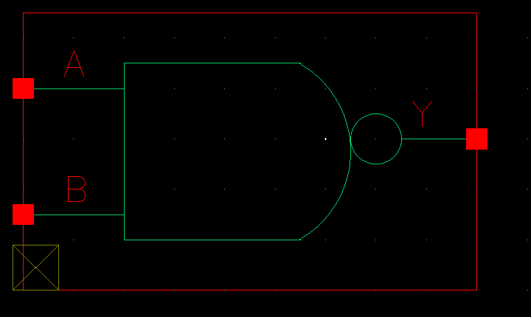
Schematic:

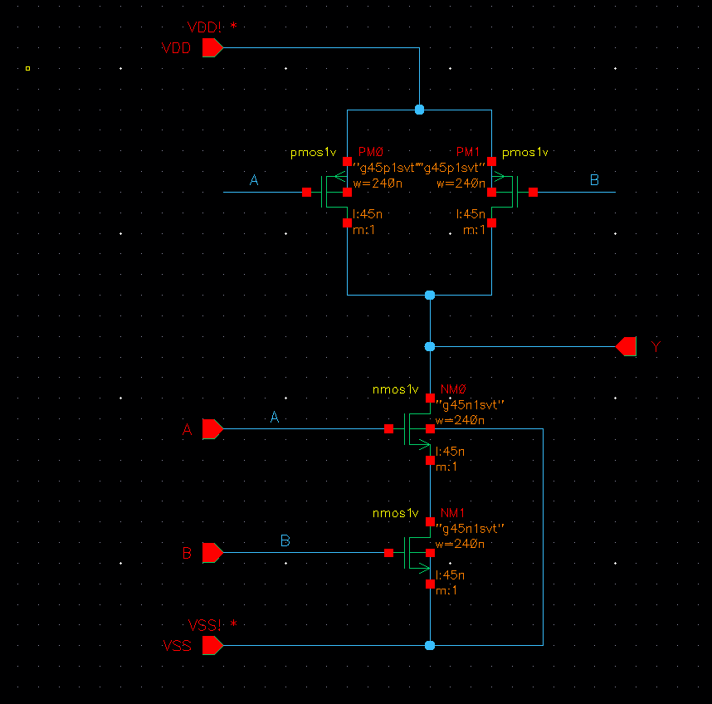
Layout:
Functional Simulation Waveforms
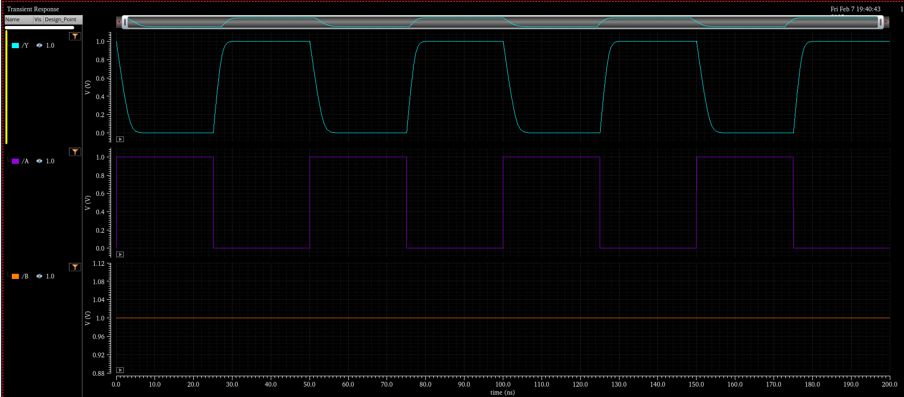

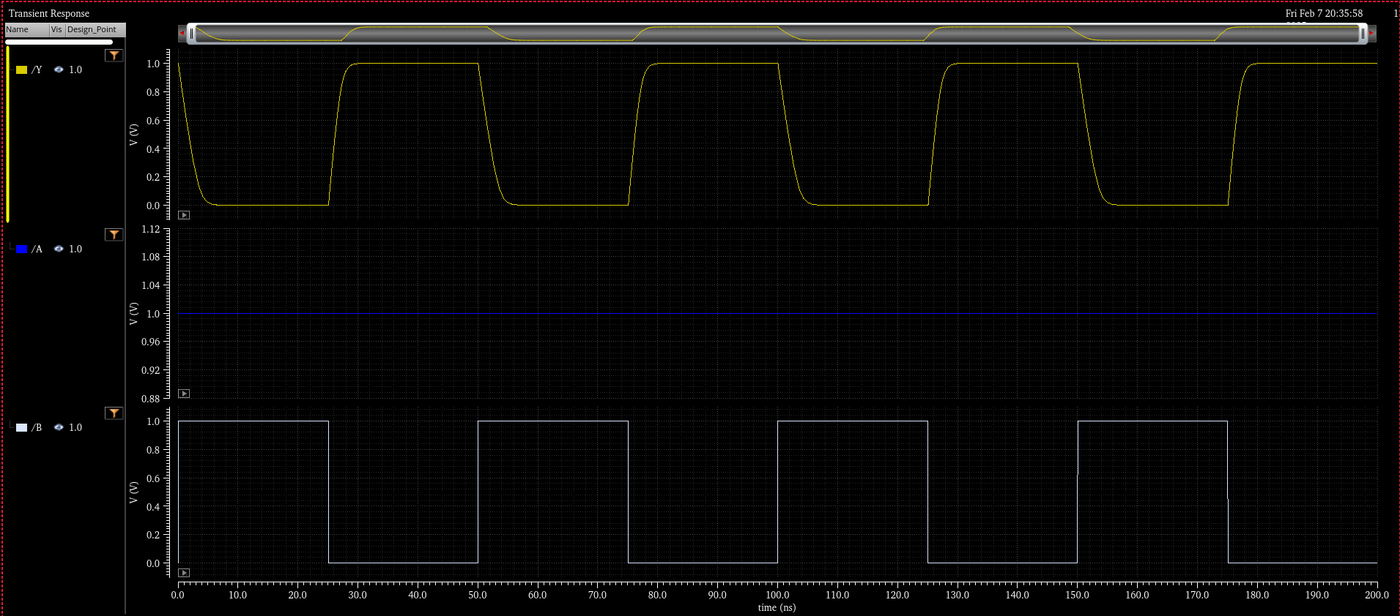

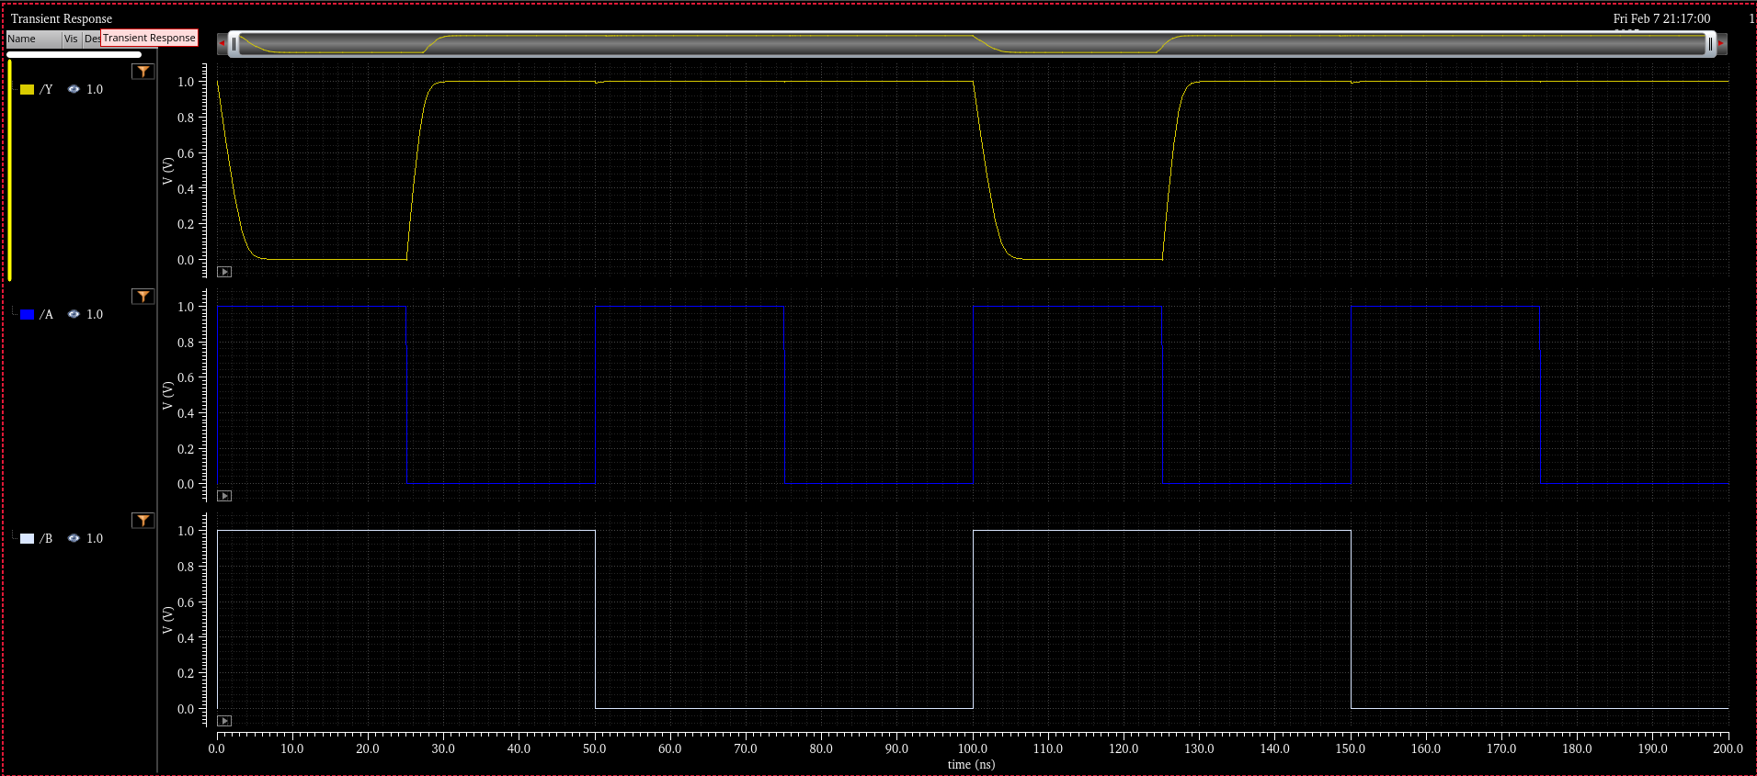
Comments/Notes:

The NAND2XI gate was successfully tested, with correct functional verification. Measured propagation delays are 1.169 ns (A → Y ↑) and 1.773 ns (A → Y ↓), with similar results for B transitions. The output rise time is slightly faster than the fall time, with values of 2.345 ns (A → Y ↑) and 3.408 ns (A → Y ↓), respectively. These results align with expected NAND gate behavior. The gate meets performance requirements, with slight asymmetry in fall times due to transistor sizing and load capacitance.

